INTEGRATIVE COURSE IN PSYCHOLOGY (ICOPSYCH)

ANALYSIS ON THE RESULT OF PRE-TEST EXAMINATION IN INDUSTRIAL PSYCHOLOGY
MARCH 15, 2025

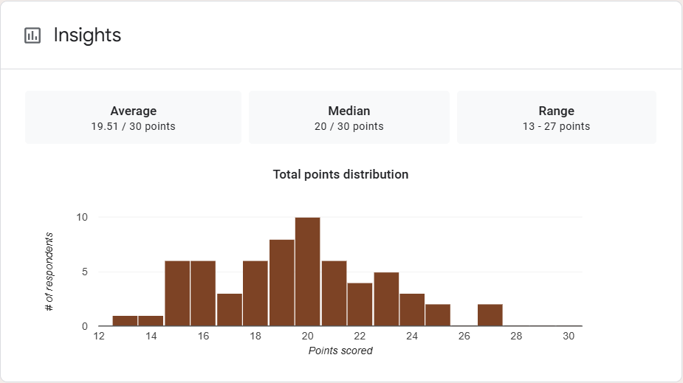

1. Mean Score: The average score of the group is approximately 19.5 out of 30. This indicates that, on average, students are scoring just below the midpoint, suggesting that the overall performance is slightly below average.

2. Median Score: The median score is 20 out of 30. This suggests that half of the students scored below 20, and half scored above 20. Since the median is slightly above the mean (19.51), it suggests there are a few lower scores pulling the average down, while most students are clustered around the higher range of scores (closer to 20).

3. Range: The range of scores is from 13 to 27 points. This suggests there is a moderate level of variation in the scores, with the lowest score being 13 and the highest being 27. This indicates a relatively broad spread of performance, with some students performing much better than others.

Interpretation Summary:

-The overall performance is somewhat average, with a few students performing notably better than others.

- The median score being slightly higher than the mean suggests that the distribution of scores may have a few low outliers.

- The range (13-27) reflects that there is significant variability in the performance, with students scoring at both ends of the spectrum.
RATIONALIZATION:

DIFFICULT QUESTIONS:

